Sprint Challenge 3
- CRISP-DM of a Predictive Analytics Project
  - Business Understanding
The sport of handball is new in terms of the analytics field, with few publications in past literature and it being a relatively modern sport in terms of Olympic introduction compared to more “mainstream” analytical pathways like international football or basketball. This paper is set to predict the outcome of handball matches and derive the most important features of the game that dictate success. By building on one of the author’s previous publications, Felice and Ley can leverage work already done in this space and enhance existing models to better address the new specified outcome. Their strategy in match prediction is unique as they are attempting to consider the match outcome from two different perspectives: a regression model predicting the number of goals scored by each team by the end of the match (allowing the authors to deduce the victor) and a classification model to directly predict the outcome as a home win, draw, or away win.
  - Data Understanding
Felice and Ley pulled from two data sources to get game information and team/player information. Within the game information data collected, there are a few standard features like day of the week or hour of the day that the game took place, but the authors also wanted to help encapsulate the potential stress of the players or their state of mind for the game (how seriously are they taking this particular contest). For example, a player would try harder in a championship than they would a friendly game, and normally at the end of the season rather than the beginning of the season. Thus, the authors created two variables: Importance (to signify the importance of the game) and Days until final (to dictate the number of days remaining until the end of the competition or season).
As far as team structure is concerned, the authors set the height, weight, and age as differences between the two teams. Segmented by position, the authors took the average of each variable for each team and calculated the difference between the two teams with a positive value meaning the home team was taller, heavier, or older. Additionally, the authors evaluated team structure as a whole, looking at travel distance to a game, and nationalities on a team.
The final element of the data collection was team strengths where Felice and Ley created estimated Attack and Defense strength for each side to assess team quality.
  - Data Preparation
The authors pulled data from additional sources and manually manipulated existing sources to insert the extraneous data. For example, the dates of the competitions that generate the feature “Days until final” were manually added, and the “Importance” feature was created by consulting professional handball experts.
Prior to any model generation, there was some necessary data cleansing that needed to be done as well. The authors found a myriad of errors within the player data such as incorrect birth years and mistyped player heights. After flagging the errored players, the authors manually updated or filled each missing record (roughly 400 of the 12,000 players in the database).
As touched on in data understanding, the authors set the height, weight, and age as differences between the two teams. Segmented by position, the authors took the average of each variable for each team and calculated the difference between the two teams with a positive value meaning the home team was taller, heavier, or older. Since this is a calculated field, that was computed using a SQL query, this is also part of the data preparation phase. As was the count of nationalities on a team and the ratio of international players selected in their national team.
  - Model Generation
This paper utilizes two different models: classification and regression.
The classification models used to predict match outcomes (win, draw, loss) are: Random Forests, XGBoost, CatBoost (specializing in categorical data), and a Multi-Layered Perceptron.
The authors explore regression models as an alternative to classification, aiming to predict the exact scores of home and away teams. They use multi-target versions of Random Forests, Gradient Boosted models, CatBoost, and Multi-Layered Perceptrons. While Random Forests and Gradient Boosted methods can theoretically manage multiple outputs, Python implementations often lack direct support, so a wrapper module is used to train separate models for each team. CatBoost and Multi-Layered Perceptron natively support multi-output predictions. Unlike approaches that only predict score differences, this method provides full score information, which is more useful for coaches and staff who need to understand both goals scored and conceded.
  - Model Evaluation
To evaluate the classification models, Felice and Ley decide to use three metrics to measure the performance of the models: accuracy, $F_{1}$ score and Brier score.
To assess the quality of their regression models, the authors elected to use Root Mean Squared Error (RMSE) and Mean Absolute Percentage Error (MAPE).
The Random Forest classification model, with the team strengths added in, performed with the highest accuracy scores – 81.32% accuracy, 79.15% $F_{1}$ score, but it had the lowest Brier score of any classification model evaluated at 0.3145. The Random Forest had an accuracy score nearly 2% higher than the CatBoost, which was the next highest, none of the other models surpassing 74%. The Random Forest model also had minimum classification error of 23.35%.
As for regression, the CatBoost, with team strengths added, performed the best – Home team RMSE of 3.79 and MAPE of 10.94% with and Away team RMSE of 3.73 and MAPE of 12.06%. Random Forest was the next closest model, and it was remarkably close – Home RMSE of 3.96 and MAPE of 11.50% and Away RMSE of 3.79 and MAPE of 12.28%. No other model had an RMSE under five or a MAPE under 14%.
  - Solution Deployment
The logistic model predicted a game outside the training and testing environment and was not far off from the final scoreline. The importance of attacking strength from one team shows a clear indication of goals to come, especially if the opponent is not as strong defensively.
The implementation of roster information, like the ratio of international call-ups on the roster or experience at certain positions, is proving to be an important driver. An indicator of team success, it can also change a team’s recruitment strategy.
- Win Probability Model
The model we discussed in class, a logistic regression, had an accuracy of around 79%. My “improved” model, a random forest model, had an accuracy of around 88%.
In order to improve the model we did in class, I first tried to create an improved logistic regression model by testing for interactions between variables and looking for confounding implications. However, I found that there was little to no improvement with this in the classification rate, and in some experiments, the classification rate even worsened from the baseline logistic regression model. Following an exploration into logistic regression, I turned to random forest modeling which turned out to be significantly more fruitful. I saw my classification rate jump nearly ten percent, and after some brief tuning by changing the mtry and increasing the number of trees, I was able to achieve a smoother graph output as well compared to my initial random forest model.
For the game of choice, I elected to apply my new win probability model to one of my favorite memories as a Packers fan – the comeback against the Chicago Bears in the first week of the 2018 season. The Packers were favored in the game, but after a poor first half from the green and gold, aside from a few moments where they threatened to score, the Bears looked poised to pull off an upset at Lambeau Field. The Packers began to show some signs of life in the second half, but the Bears were in position to hold on for the win until the end when the Packers came back and took the lead to steal the victory.
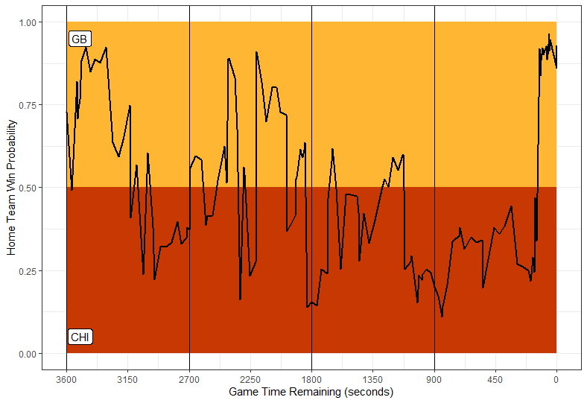
There are a few important points to make regarding the model that I would be remiss if I did not acknowledge. Firstly, the major swing of the game in question resulted from an injury to the Packers starting quarterback Aaron Rodgers in which he left early in the first quarter and looked like he would be missing the entire season. Then he returned to start the second half and sparked one of the best comebacks of the team’s storied history. Player status or availability is not considered in the model. Secondly, and related to that, it is important to note the limitations of these win probability models. The random forest model, while excellent at classification, its predictions can look “jagged” or overly aggressive when plotted play‑by‑play. That is because each tree votes independently, and the ensemble can swing sharply when the input features change even slightly. The logistic regression model on the other hand presents a much more intuitive picture of win probability when graphed on a play-by-play basis but is a worse classifier. The above image is my random forest model that provided the better classifier score, but I think if I were to look at ESPN or any kind of application that displays win probability, they probably sacrifice some of the classification accuracy for user friendly graphs and utilize a logistic model.
- Customer Retention Model
Since we are looking to craft a retention model, I was thinking about investigating the populations that have had the largest growth and are currently serving as the largest in the stadium. From my perspective, the more people you can get into the stadium, the more revenue you can generate and the more chances you get to retain customers. In the interest of retaining growing populations, I evaluated the classes within the stadium and found that the general admission tickets were growing exponentially faster than either club or suite. I also saw a dramatic difference in their volume. To me, that signaled an opportunity to establish a strong foundational fanbase to utilize and grow an in-stadium atmosphere/crowd from there.
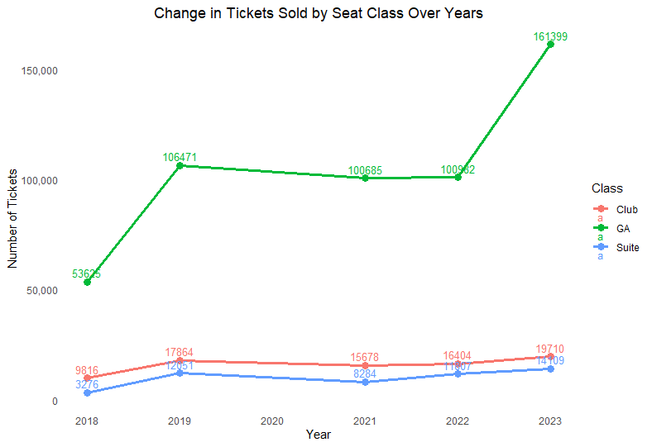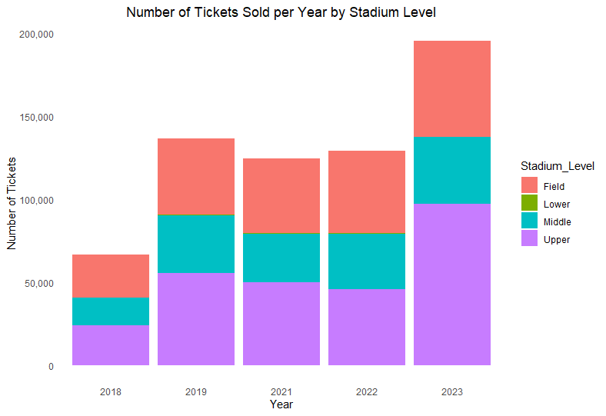
Then I thought about the construction of a stadium and how there are different available seating options at different tiers. So, I looked at the plot we created in class regarding ticket sales by stadium level and then isolated the best selling levels: field and upper. I wanted to know which set of fans was driving the sale of those tickets and unsurprisingly, it was the same group of fans that was driving up the volume all around the stadium: general admission or GA. They made up 96% of the field level sales and 100% of the upper level sales. This cemented my belief that GA tickets would be a smart target for a customer retention model due to their volume and breadth across the stadium.
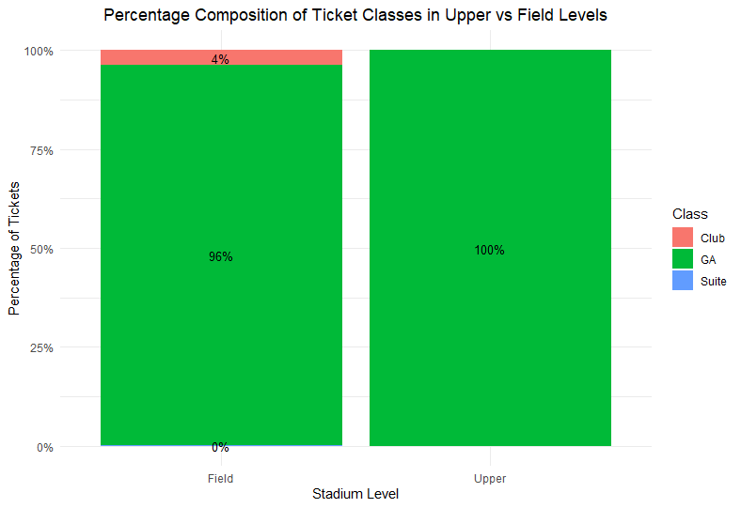

My analysis is similar to the model we constructed in class, but targeting the GA population rather than the entire season ticket holder population. I filtered the model prior to running to only look at GA tickets and then proceeded on with the same general process. I altered the model to take out Most_Frequent_Class since I was only evaluating for one class, general admission, and it would be redundant or useless to leave that variable to leave in.
I would tell business personnel that in order to retain our general admission patrons in the short term, we should focus on the people who are attending the games they own the tickets for and put extra effort into making the gameday experience pleasurable at the upper and field levels. The model showed that stadium level and non-resale tickets were big drivers of accuracy, so leveraging these points can help with strategy in the short term. In the longer term, I would describe to the business personnel how we expect the model results to change. Ideally that would include increased attendance among the other populations, a lesser reliance on just general admission funds, and potentially an on-field performance boost to aide in fan intrigue (playoff and win percentage scores indicate the team has been struggling as of late). If we stick with targeting general admission fans though, on field performance would impact not only fan interest in the game in terms of attendance, but potentially from the resale perspective which could drive retention up as well. We already saw that as a strong factor, but its impact could become even more apparent.

felice-ley-2025-predicting-handball-matches-with-machine-learning-and-statistically-estimated-team-strengths.pdf

